***PRINCE BAIDOO GYAN.***

***31st OCTOBER 2019.***

***IPMC SOFTWARE ENGINEERING YEAR 1.***

***PROJECT 1.***

***CONTENT***

* *INTRODUCTION*
* *OBJECTIVE AND SCOPE OF THE PROJECT*
* *SYSTEM ANALYSIS AND DESIGN*
* *METHODOLOGY ADOPTED, SYSTEM IMPLEMENTATION AND DETAILS OF HARDWARE AND SOFTWARE USED*
* *FLOW CHART*
* *SAMPLE OUTPUT*
* *SOURCE CODE*
* *CONCLUSION*

***INTRODUCTION OF PROJECT***

*In my project concerning with “****HOTOR COMPANY LIMITED”,*** *a computerized system needs to be implemented for efficiency, since* ***the*** company’s manual system takes longer time if there are large number of processes and its efficiency is very low. The company has now acquired large number of Halls.

In today’s world managing systems with computer application and programs has totally changed. There are many errors and drawbacks without the use of computer programming and application.

As we know that, “necessity is the mother of invention”, so in today’s challenging world, every system is developed and launched by the use of computer software and programming.

***USER CAN GET THESE FACILITIES FROM THIS PROJECT***

* *User can maintain customer records for a long time.*
* *User can check all details of customers.*

***OBJECTIVE AND SCOPE OF THE PROJECT***

*I have developed this project for “****HOTOR COMPANY LIMITED”*** *which is to book dining halls. In this system the objectives of the project are as follows:*

* *To minimize the workload involved in manual procedures of checking the record and subsequently increase the efficiency and accuracy.*
* *To reduce the paper work by allowing all format to be maintained in the system.*
* *To provide an easy way of handling the multiple records and to be able to get rid of big and clumsy records.*
* *To optimize the efficiency of establishment to reduce manpower there by making the procedures to be less expensive.*
* *To allow speedy retrieval of information by making all the information just one click away.*
* *To easy access and generate any kind of report regarding the status of any client.*
* *To be able to deliver the information at any time whenever required quickly and accurately.*

***SYSTEM ANALYSIS AND DESIGN***

***Requirement summary***

*The following preliminary details are based on initial interviews.*

***Business requirement***

*The business goal for the application is to support an increase in the productivity and complete automation of the previous manual bill and invoice generation process. Business requirement are discussed in the scope section, with the following additional details.*

*To enable them to accomplish this goal, they want extract meaningful data that easily answers the following questions.*

* *What are the early warning signs of problems?*
* *Who are my best clients?*
* *With whom do I focus my effort for building a long-term relationship?*
* *What are my clients issues as a company?*
* *What services are my clients buying and at what rate?*

***User requirement***

***Receptionist***

* *Update records, include customer and bill.*
* *Add, delete and update customer and bill.*
* *Record specifications.*
* *Generate report and check the availability when needed.*

***Operational requirement***

*The following requirements provide a high-level view of how the system will run:*

* *All input is to be entered appropriately and accordingly.*
* *Processor usage should not exceed 1gb before the application.*
* *Ensure that the information is easy to access.*
* *Any changes to the information must be reflected immediately and the changes must be propagated to the system to see the new information.*

***METHODOLOGY ADOPTED, SYSTEM IMPLEMENTATION AND DETAILS OF HARDWARE AND SOFTWARE USED.***

***Software requirement***

***Minimum requirement***

* *Windows operating system*
* *C++ IDE*

***Hard requirement***

***Minimum requirement***

* *Processor - Pentium 3 and above*
* *Ram – 512mb and above*
* *Hard disk – 20gb and above*
* *Screen*
* *Keyboard*
* *Mouse*

***DATA FLOW CHART***

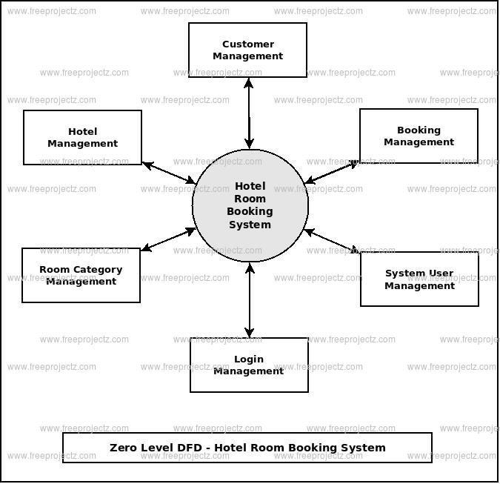

***SAMPLE OUTPUT***

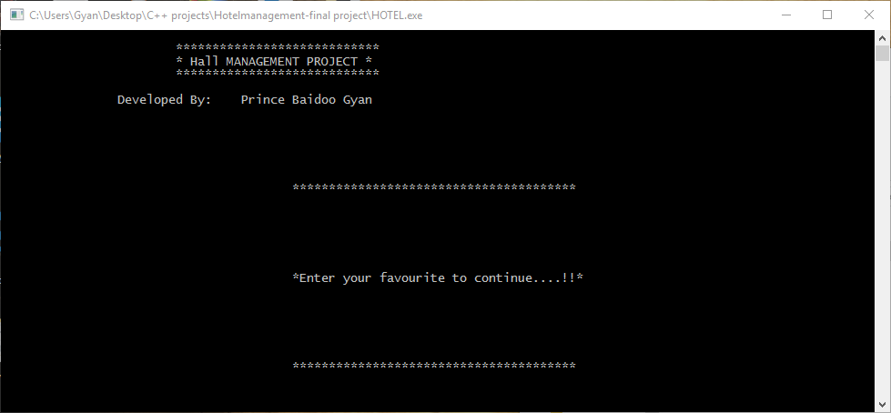

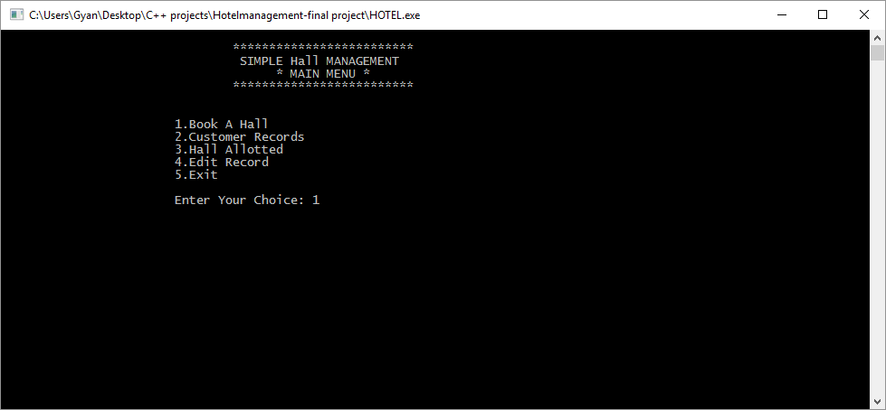

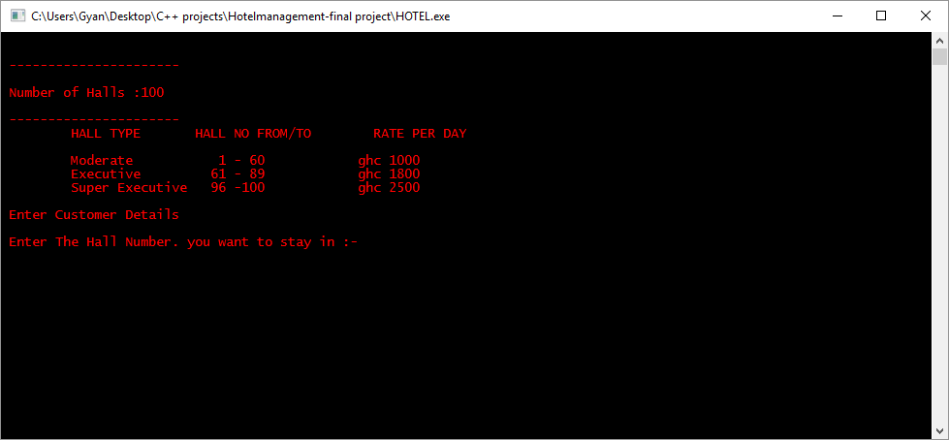

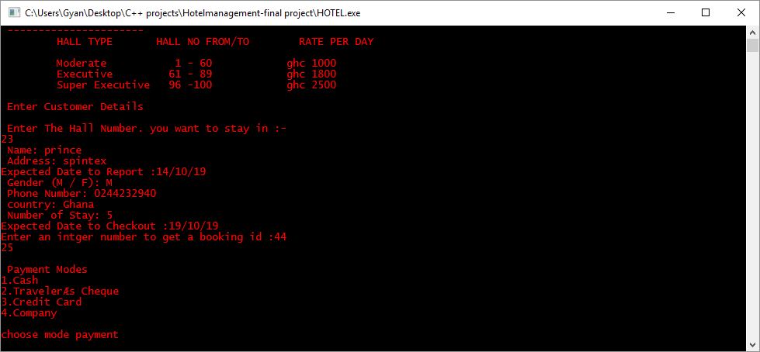

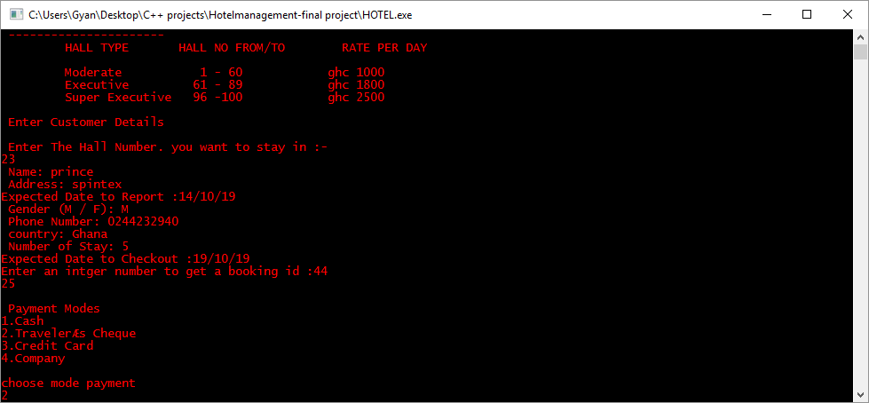

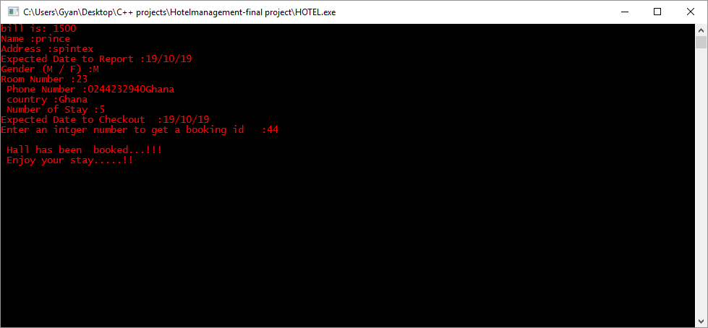

***SOURCE CODE***

*//C++ PROJECT*

*//START OF THE PROGRAM FOR HOTEL MANAGEMENT*

*#include<iostream>*

*#include<conio.h>*

*#include<fstream>*

*#include<stdio.h>*

*#include<stdlib.h>*

*#include<dos.h>*

*#include <ctime>*

*#include <cstdlib>*

*using namespace std;*

*//START OF CLASS*

*class hotel*

*{*

*int room_no;*

*char name[30];*

*char address[50];*

*char phone[10];*

*char country[20];*

*char Gender;*

*int days;*

*char date[10];*

*public:*

*void main_menu(); //to dispay the main menu*

*void add(); //to book a room*

*void display(); //to display the customer record*

*void rooms(); //to display alloted rooms*

*void edit(); //to edit the customer record*

*int check(int); //to check room status*

*void modify(int); //to modify the record*

*void delete_rec(int); //to delete the record*

*void bill(int); //for the bill of a record*

*void cash(); //for the payment modes without discount*

*void Cheque(); // to multiply the discount base on the payment mode*

*void Credit_card(); //to multiply the discount base on the payment mode*

*void company(); // to multiply the discount base on renounce companies and non-renounce*

*};*

*//END OF CLASS*

*//FOR DISPLAYING MAIN MENU*

*void hotel::main_menu()*

*{*

*int choice;*

*while(choice!=5)*

*{*

*//FOR DISPLAYING MAIN MENU*

*system("cls");*

*cout<<"\n\t\t\t\t*************************";*

*cout<<"\n\t\t\t\t SIMPLE Hall MANAGEMENT ";*

*cout<<"\n\t\t\t\t * MAIN MENU *";*

*cout<<"\n\t\t\t\t*************************";*

*cout<<"\n\n\n\t\t\t1.Book A Hall";*

*cout<<"\n\t\t\t2.Customer Records";*

*cout<<"\n\t\t\t3.Hall Allotted";*

*cout<<"\n\t\t\t4.Edit Record";*

*cout<<"\n\t\t\t5.Exit";*

*cout<<"\n\n\t\t\tEnter Your Choice: ";*

*cin>>choice;*

*switch(choice)*

*{*

*case 1: add();*

*break;*

*case 2: display();*

*break;*

*case 3: rooms();*

*break;*

*case 4: edit();*

*break;*

*case 5: break;*

*default:*

*{*

*cout<<"\n\n\t\t\tWrong choice.....!!!";*

*cout<<"\n\t\t\tEnter your favourite to continue....!!";*

*getch();*

*}*

*}*

*}*

*}*

*//END OF MENU FUNCTION*

*//FUNCTION FOR BOOKING OF HALLS*

*void hotel::add()*

*{*

*//FUNCTION FOR BOOKING OF HALLS*

*system("cls");*

*int r,flag;*

*ofstream fout("Record.dat",ios::app);*

*system("color c");*

*//Type of halls and the cost involved respectively*

*cout<<"\n\n ----------------------";*

*cout<<"\n\n Number of Halls :100 ";*

*cout<<"\n\n ----------------------";*

*cout<<"\n\t HALL TYPE\t HALL NO FROM/TO\tRATE PER DAY";*

*cout<<"\n";*

*cout<<"\n\t Moderate\t 1 - 60\t ghc 1000 ";*

*cout<<"\n\t Executive\t 61 - 89\t ghc 1800";*

*cout<<"\n\t Super Executive 96 -100 ghc 2500";*

*cout<<endl;*

*cout<<"\n Enter Customer Details"<<endl;*

*cout <<"\n Enter The Hall Number. you want to stay in :- "<<endl;*

*cin>>r;*

*//End of the hall types*

*int max, random_number,i;//creating variables to help generate numbers n it own*

*flag=check(r);*

*if(flag)*

*cout<<"\n Sorry..!!!Room is already booked";*

*else*

*{*

*//Entering details of the customer*

*room_no=r;*

*cout<<" Name: ";*

*cin>>name;*

*cout<<" Address: ";*

*cin>>address;*

*cout<<"Expected Date to Report :";*

*cin>>date;*

*cout<<" Gender (M / F): ";*

*cin>>Gender;*

*cout<<" Phone Number: ";*

*cin>>phone;*

*cout<<" country: ";*

*cin>>country ;*

*cout<<" Number of Stay: ";*

*cin>>days;*

*cout<<"Expected Date to Checkout :";*

*cin>>date;*

*cout<<"Enter an intger number to get a booking id :";*

*cin>>max;*

*//End of entering details of the customer*

*//this code is for generating the booking id*

*srand(time(0));*

*random_number = (rand () %max)+1;*

*cout<<random_number<<endl;*

*//end of code for generating the booking id*

*int mode=0;//delaring a variable for the payment modes*

*//Selecting a payment mode the customer want to use*

*cout<<"\n Payment Modes"<<endl;*

*cout<<"1.Cash"<<endl;*

*cout<<"2.Traveler’s Cheque"<<endl;*

*cout<<"3.Credit Card"<<endl;*

*cout<<"4.Company "<<endl;*

*cout<<endl;*

*cout<<"choose mode payment"<<endl;*

*cin>>mode;*

*system("cls");*

*// options the customer want to choose*

*switch(mode){*

*case 1: cash();*

*break;*

*case 2: Cheque();*

*break;*

*case 3: Credit_card();*

*break;*

*case 4: company();*

*break;*

*default:cout<<"No option choosen"<<endl;*

*break;*

*}*

*//End of options customer want to choose*

*//print all the details of the customer*

*cout<<"Name :"<<name<<endl;*

*cout<<"Address :"<<address<<endl;*

*cout<<"Expected Date to Report :"<<date<<endl;*

*cout<<"Gender (M / F) :"<<Gender<<endl;*

*cout<<"Room Number :"<<room_no<<endl;*

*cout<<" Phone Number :"<<phone<<endl;*

*cout<<" country :"<<country<<endl;*

*cout<<" Number of Stay :"<<days<<endl;*

*cout<<"Expected Date to Checkout :"<<date<<endl;*

*cout<<"Enter an intger number to get a booking id :"<<max<<endl;*

*//File handing to help store records*

*fout.write((char*)this,sizeof(hotel));*

*cout<<"\n Hall has been booked...!!!";*

*}*

*cout<<"\n Enjoy your stay.....!!";*

*getch();*

*fout.close();*

*}*

*//END OF BOOKING FUNCTION*

*//FUNCTION FOR DISPLAYING A PURTICULAR CUSTOMER`S RECORD*

*//for the payment modes without discount*

*void hotel::cash(){*

*float bill = 0;*

*if(room_no <= 60){*

*bill = 1000 * days;*

*}*

*else if(room_no > 60 && room_no < 89){*

*bill = 1800 * days;*

*}*

*else{*

*bill = 2500 * days;*

*}*

*cout<<"bill is: "<<bill<<endl;*

*};*

*//End of function for paying in cash*

*//to multiply the discount base on the payment mode*

*void hotel::Cheque(){*

*float bill =0;*

*if(room_no<=60){*

*bill = (1000 * days) * 0.3;*

*}*

*else if(room_no>60 && room_no<89){*

*bill = (1800 * days) * 0.3;*

*}*

*else{*

*bill = (2500 * days) * 0.3;*

*}*

*cout<<"bill is: "<<bill<<endl;*

*};*

*//End of function for paying in cheque*

*//to multiply the discount base on the payment mode*

*void hotel::Credit_card(){*

*float bill =0;*

*if(room_no<=60){*

*bill = (1000 * days) * 0.4;*

*}*

*else if(room_no>60 && room_no<89){*

*bill = (1800 * days) * 0.4;*

*}*

*else{*

*bill = (2500 * days) * 0.4;*

*}*

*cout<<"bill is: "<<bill<<endl;*

*};*

*//End of function for paying in Credit card*

*// to multiply the discount base on renounce companies and non-renounce*

*void hotel::company(){*

*string companyName[4]{"Cal","Mtn","Tigo"};*

*float bill=0;*

*string userinput;*

*float discount=0.07;*

*cout<<"Enter company name"<<endl;*

*cin>>userinput;*

*for(int i=0;i<1;i++){*

*if(userinput==companyName[i]){*

*discount = 0.12;*

*}*

*if(room_no<=60){*

*bill = (1000 * days) * discount;*

*}*

*else if(room_no>60 && room_no<89){*

*bill = (1800 * days) * discount;*

*}*

*else{*

*bill = (2500 * days) * discount;*

*}*

*cout<<"bill is: "<<bill<<endl;*

*}*

*}*

*//End of function for paying in company*

*//to display the customer record*

*void hotel::display()*

*{*

*system("cls");*

*ifstream fin("Record.dat",ios::in);*

*int r,flag;*

*cout<<"\n Enter room no. for a particular customer`s details :- "<<endl;*

*cin>>r;*

*while(!fin.eof())*

*{*

*fin.read((char*)this,sizeof(hotel));*

*if(room_no==r)*

*{*

*system("cls");*

*cout<<"\n Cusromer Details";*

*cout<<"\n ----------------";*

*cout<<"\n\n Room no: "<<room_no;*

*cout<<"\n Name: "<<name;*

*cout<<"\n Address: "<<address;*

*cout<<"\n Phone no: "<<phone;*

*flag=1;*

*break;*

*}*

*}*

*if(flag==0)*

*cout<<"\n Sorry Room no. not found or vacant....!!";*

*cout<<"\n\nEnter your favourite to continue....!!";*

*getch();*

*fin.close();*

*}*

*//END OF DISPLAY FUNCTION*

*//FUNCTION TO DISPLAY ALL ROOMS OCCUPIED*

*void hotel::rooms()*

*{*

*system("cls");*

*ifstream fin("Record.dat",ios::in);*

*cout<<"\n\t\t\t List Of Rooms Allotted";*

*cout<<"\n\t\t\t ----------------------";*

*cout<<"\n\n Room No.\tName\t\tAddress\t\t\t\tPhone No.\n";*

*while(!fin.eof())*

*{*

*fin.read((char*)this,sizeof(hotel));*

*cout<<"\n\n "<<room_no<<"\t\t"<<name;*

*cout<<"\t\t"<<address<<"\t\t"<<phone;*

*}*

*cout<<"\n\n\n\t\t\tEnter your favourite to continue.....!!";*

*getch();*

*fin.close();*

*}*

*//FUNCTION FOR EDITING RECORDS AND FOR BILL*

*void hotel::edit()*

*{*

*system("cls");*

*int choice,r;*

*cout<<"\n EDIT MENU";*

*cout<<"\n ---------";*

*cout<<"\n\n 1.Modify Customer Record";*

*cout<<"\n 2.Delete Customer Record";*

*cout<<"\n 3. Bill Of Customer";*

*cout<<"\n Enter your choice: ";*

*cin>>choice;*

*system("cls");*

*cout<<"\n Enter Hall Number: " ;*

*cin>>r;*

*switch(choice)*

*{*

*case 1: modify(r);*

*break;*

*case 2: delete_rec(r);*

*break;*

*case 3: bill(r);*

*break;*

*default: cout<<"\n Wrong Choice.....!!";*

*}*

*cout<<"\n Enter your favourite to continue....!!!";*

*getch();*

*}*

*int hotel::check(int r)*

*{*

*int flag=0;*

*ifstream fin("Record.dat",ios::in);*

*while(!fin.eof())*

*{*

*fin.read((char*)this,sizeof(hotel));*

*if(room_no==r)*

*{*

*flag=1;*

*break;*

*}*

*}*

*fin.close();*

*return(flag);*

*}*

*// End FUNCTION FOR EDITING RECORDS AND FOR BILL*

*//FUNCTION TO MODIFY CUSTOMERS RECORD*

*void hotel::modify(int r)*

*{*

*long pos,flag=0;*

*fstream file("Record.dat",ios::in|ios::out|ios::binary);*

*while(!file.eof())*

*{*

*pos=file.tellg();*

*file.read((char*)this,sizeof(hotel));*

*if(room_no==r)*

*{*

*cout<<"\n Enter New Details";*

*cout<<"\n -----------------";*

*cout<<"\n Name: ";*

*cin>>name;*

*cout<<" Address: ";*

*cin>>address;*

*cout<<" Phone no: ";*

*cin>>phone;*

*file.seekg(pos);*

*file.write((char*)this,sizeof(hotel));*

*cout<<"\n Record is modified....!!";*

*flag=1;*

*break;*

*}*

*}*

*if(flag==0)*

*cout<<"\n Sorry Room no. not found or vacant...!!";*

*file.close();*

*}*

*//END OF MODIFY FUNCTION*

*//FUNCTION FOR DELETING RECORD*

*void hotel::delete_rec(int r)*

*{*

*int flag=0;*

*char ch;*

*ifstream fin("Record.dat",ios::in);*

*ofstream fout("temp.dat",ios::out);*

*while(!fin.eof())*

*{*

*fin.read((char*)this,sizeof(hotel));*

*if(room_no==r)*

*{*

*cout<<"\n Name: "<<name;*

*cout<<"\n Address: "<<address;*

*cout<<"\n Pone No: "<<phone;*

*cout<<"\n\n Do you want to delete this record(y/n): ";*

*cin>>ch;*

*if(ch=='n')*

*fout.write((char*)this,sizeof(hotel));*

*flag=1;*

*}*

*else*

*fout.write((char*)this,sizeof(hotel));*

*}*

*fin.close();*

*fout.close();*

*if(flag==0)*

*cout<<"\n Sorry room no. not found or vacant...!!";*

*else*

*{*

*remove("Record.dat");*

*rename("temp.dat","Record.dat");*

*}*

*}*

*//END OF DELETE FUNCTION*

*//FUNCTION FOR CUSTOMER`S BILL*

*void hotel::bill(int r)*

*{*

*hotel h1;*

*ifstream f1;*

*f1.open("record.dat",ios::in|ios::binary);*

*if(!f1)*

*cout<<"cannot open";*

*else*

*{*

*f1.read((char*)&h1,sizeof (hotel));*

*while(f1)*

*{*

*f1.read((char*)&h1,sizeof(hotel));*

*}*

*if (h1.room_no == r)*

*{*

*if(h1.room_no>=1&&h1.room_no<=30)*

*cout<<"your bill = 2000";*

*else if (h1.room_no>=35&&h1.room_no<=45)*

*cout<<"your bill = 5000" ;*

*else*

*cout<<"your bill = 7000";*

*}*

*else*

*{ cout<<"room no. not found";}*

*}*

*f1.close();*

*getch();*

*}*

*//END OF BILLING FUNCTION*

*//START OF MAIN PROGARM*

*int main()*

*{*

*void bar();*

*hotel h;*

*system("cls");*

*cout<<"\n\t\t\t****************************";*

*cout<<"\n\t\t\t* Hall MANAGEMENT PROJECT *";*

*cout<<"\n\t\t\t****************************";*

*cout<<"\n\n\t\tDeveloped By:";*

*cout<<"\t Prince Baidoo Gyan";*

*cout<<"\n\n\n\n\n\n\n\t\t\t\t\t***************************************";*

*cout<<"\n\n\n\n\n\n\n\t\t\t\t\t*Enter your favourite to continue....!!*";*

*cout<<"\n\n\n\n\n\n\n\t\t\t\t\t***************************************";*

*getch();*

*h.main_menu();*

*return 0;*

*}*

*//END OF MAIN PROGRAM*

***CONCLUSION***

***Program weakness:***

*As we all know that, no program can be 100% reliable and efficient. So there are also some drawbacks from my system which are as follows:*

* *It can perform all the functions as a hall booking system.*
* *System is not sharply graphical user interface. There is just use of some text color.*
* *It’s not a multiuser and multitasking program. It is can’t perform various task at a single time.*

***Program strength:***

* *It is actually a user friendly software, as it is just easy to use by just following the instructions that appear on the screen.*
* *Once a record has been saved, duplicate records can’t be made.*